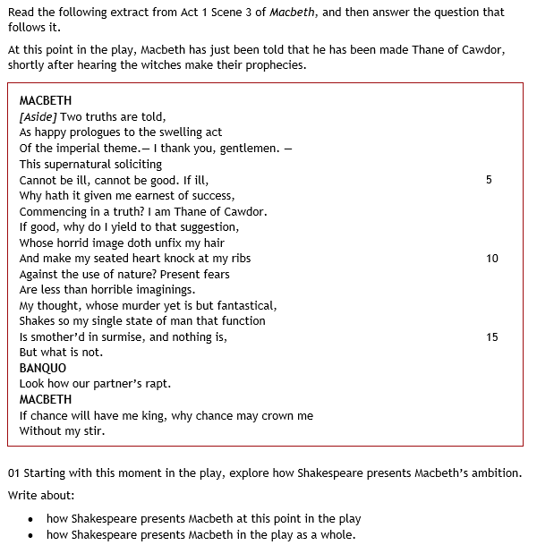

In Act 1 scene 3, Macbeth’s ambitions are portrayed as somewhat realistic and achievable. At the end of the extract, Macbeth mentions that “If chance will have me king, why chance may crown me without my stir.” This indicates to use that Macbeth sees his kingship as something that may not even happen. He does want to be King and believes that it would be beneficial but at this point in the play, he doesn’t feel it is close enough for actions to take place. This also proves his humbleness and honour for the King Duncan. He respects his superior far too much to actually do anything to worsen his life and this shows how little he cares for his own ambition; he wants to see others do well. The use of the word “chance” is also crucial. Macbeth sees his kingship as something that may or may not happen and something that is just a possibility. He is aware that being King is a huge role and something that is also very hard to get, so because of this, he doesn’t think too much of it. This proves that he has realistic goals at this point in the play. He doesn’t want to think of something that seems close to impossible and would rather silence his own ambition in order to refrain from becoming greedy and power-hungry. This allows a reader to feel respect towards Macbeth’s character and means that he is someone we want to see do well. We have already heard what a great warrior he is and this makes his dark turn all the more disappointing. However, some people believe that Macbeth is interested at this point. The stage directions explain to us how this conversation was “aside” and this makes it seem as if Macbeth is sharing a secret. He wants to express his true feelings and feels that he can’t in public, which seems reasonable. However, the fact that Macbeth talked about this alone suggests that he has some opinion on it and values it quite a lot. I disagree with this however and believe that it is just gossip between two friends that no-one would understand. After all, who would take something so calmly if Macbeth mentioned that he encountered real witches, who at the time were seen as malevolent and powerful monsters.

However, Macbeth’s ambitions begin to grow at the end of his famous dagger soliloquy. The soliloquy ends in a chilling rhyming couplet that hears him say “Hear it not Duncan, for it is a knell, that summons thee to Heaven or Hell,” This sickening quote happens right before the King’s murder. We see Macbeth primed, ready and composed before a key turning point in the play and this emphasises how much the character has changed. For the first time, Macbeth knows what he wants and he knows how to get it. He doesn’t want to mess about and is silencing all of his doubts in order for him to execute an evil and cruel deed. The use of the word “knell” suggests that something terrible will happen, that the King’s death is almost guaranteed and almost as if consequences will follow it. Even the word makes it sound as if there is a lot more to come from this one act. In Shakespearean writing, rhyming couplets are used to end a thought. This rhyming couplet is used to say that Macbeth has made a decision and there is no element of doubt from this point on. This differs to the Macbeth we saw previously. This Macbeth no longer believes in chance and believes that he needs to do something to get what he wants; he is impatient. Macbeth’s ambition has done this as well. It seemed as if Macbeth always wanted something and the ambition was there when he asked for the witches to tell him more ins Act 1 scene 3, however know, he believes fully in it and is willing to actually carry it out himself to get what he wants faster. This would make a reader disappointed in Macbeth who we wanted to do well. We truly believed that he was the hero, but in a matter of moments, we see him become a notorious villain. Now Macbeth would still be a hero with his ambitions in place but what makes a hero heroic, is their ability to resist temptation and do the right thing. Here Macbeth has broken all of the boundaries. What Shakespeare may be trying to say through this portrayal of Macbeth is that it is OK to want something, but it is not OK to cheat your way around it. Some people may believe that Macbeth has not turned at this point and it was just a spur of the moment thing caused by unimaginable manipulation and torment. They may think that the quote “hear it not” expresses Macbeths true shame and guilt however I disagree with this whole theory. Again, Shakespeare’s rhyming couplets are used to show that a character has made up his/her mind and that decision is final. Lady Macbeth did not make Macbeth’s decision. Yes, she played a big role in it but when Macbeth was left alone, he came to his own personal decision and decided to kill Duncan

Finally, at the end of the play, Macbeth’s ambition makes him feel unstoppable. He is given one bit of good news and he believes that his life is set. Ironically, before Macbeth’s death, he states that he “Bears a charmed life”. Although this may seem like arrogance and over confidence, it is also ambition. He believes that he can win anything and that nothing will stand in his way. The tyrant is in no way frightened of any threat and believes that he will be able to do whatever he pleases until he eventually dies of old age. This suggests that the character views himself almost as a god in the sense that he is superior to everyone else and will live a joyful life that no one will ever be able to deprive him of. So now, in contrast the start of the play, Macbeth his wild ambitions. He thinks that anything is possible when in truth it is not. This shows the danger of ambition and how it can lead to greed. Greed is different to ambition in my opinion. The way I see it, greed is when someone wants everything no matter how big or small and the belief that everything is going to happen for you. Ambition on the other hand is a catalyst for producing great performances that earn the reward they *deserve.* The use of the word “Bear” connotes that Macbeth has something that no one else does. He wants everyone to know that he is special and wants everyone to feel inferior to him. This makes him seem arrogant and confident in the sense that he knows (or at least thinks he knows) how everything will end and why. At this point in the play, we feel as an audience as if it is over for everyone. The witches have only spoken the truth for so long and Macbeth is just reminding us that he is unstoppable. This makes it seem as if there is no hope but when Macduff reveals himself as the inevitable hero minutes later, it will seem as if this ending is not set and this makes the end even more thrilling. Maybe Shakespeare is trying to show at this point that ambition can be dangerous. People can want something so much to the point where they are willing to do anything for it and when they get what they want, the feel special and as if the world is theirs. The writer is also saying that just because you are in ways greater to other people, no one is a god and no one will ever be perfect. In Macbeth we see how one thing lead to another. He wanted to be King, he got it and felt special. However, he cheated his way there and received punishments for greater than what he could ever expect. Some people may believe that this ending sees Macbeth now becoming masculine and stepping up for once however I disagree with this. Being masculine is not about being able to commit terrible deeds or betray the people closest to you, it’s about the ability to stay strong and do the right thing. In Macbeth, I believe that neither Lady Macbeth or Macbeth are ever masculine, they’re just plain monsters. They are able to summon up courage yes, but there is nothing masculine about murder, that is just psychotic. The real masculine figure in this play is Macduff. Macduff is a man who takes responsibility and tries his very best to redeem himself when things go wrong. He does not hide away and ignore the things going on. Unlike Macbeth, he uses his ambition for good things and for other people, hence making him masculine.