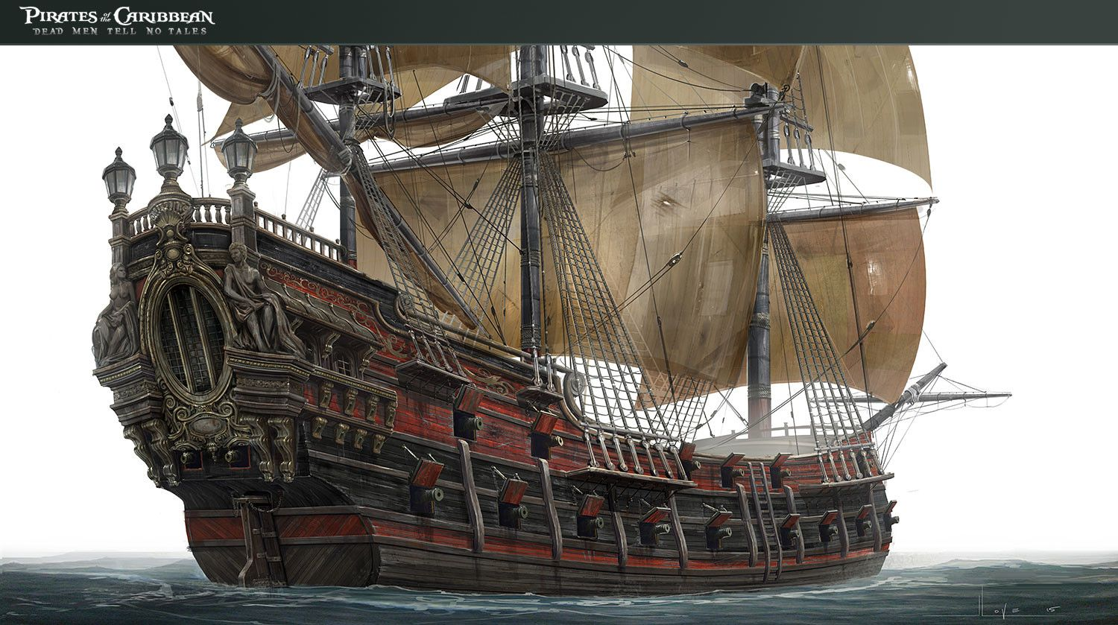

I have chosen this setting as the ship can be used as a metaphor as whatever happens, everyone on the ship will soon find out and know what happened. I think using the ship would be very effective as there are storms that can be used at appropriate times in the play. Using the ship is clever in a way as it will work with the advantage that Macbeth turns into a ship out of control in the play. Whilst on a ship, you can’t escape what you have done and have to face the consequences there and then.