

Reminder: Please use the Bekind email address to contact us if required. bekind@parkside.org.uk  
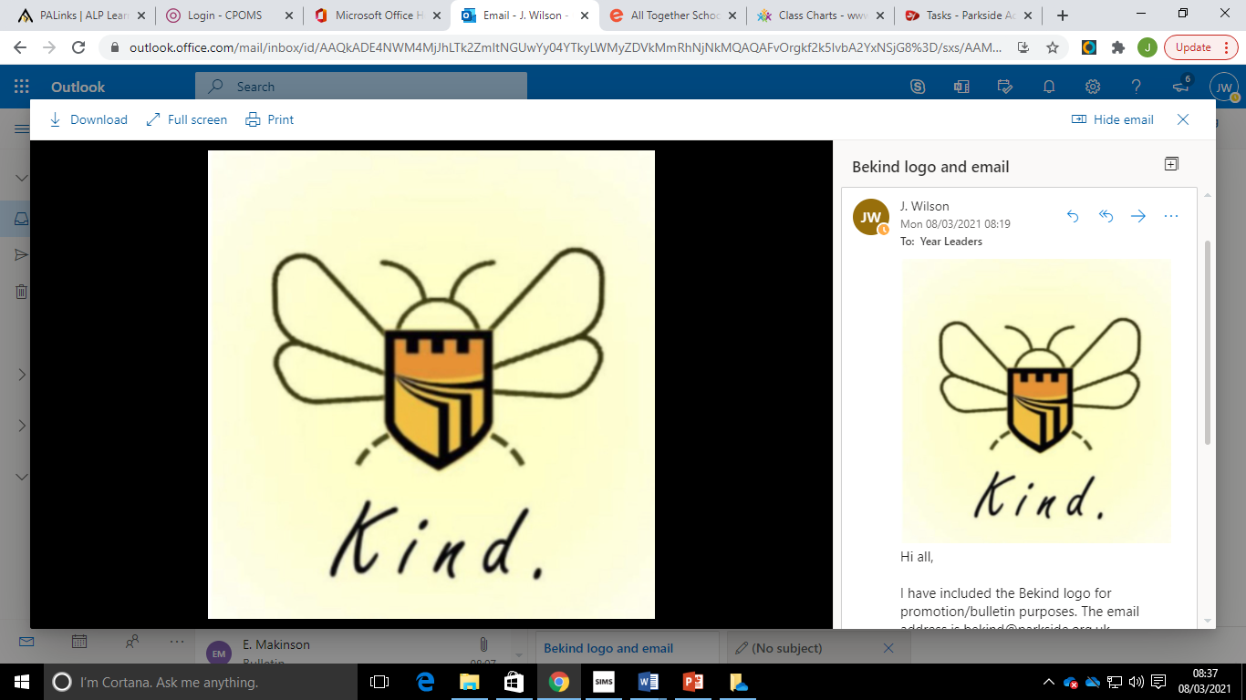

**Subject Shout Outs**  
 **Geography –** Sky M, Callum H **English** – Jack H, Callum H, Michael T  
**Sports Studies** – Kian P, Matthew S, Roma KH, Mason C, Joe M  
**RE** – Dylan D, Grace R, Roma KH, Katie M, Sky M, Ellie F  
**German** - Ebonie T, Lana F, Sabela D, Xena T, Isabel I, Nathan E  
**Business –** Matthew S, Matthew J, Xena T, Jessica G, Evie S, Jessica W  
**Travel** – Harley W, James H, Grace R, Daniel G

**Top Achievement Points**

**(We gained 109 points last week!)**

*The following pupils were awarded the highest number of achievement points last week – brilliant work!*

*Daniel G (9D) - 15 points*

*Jessica J (VV) – 10 points*

*Spencer N (9S) – 5 points*

*Michael T (9D) – 5 points*

*Kai K (9K) – 5 points*

**Literacy Challenge**Remember to check out the Masked Reader this week on our Facebook page. Can you guess who the teacher is and what book they are reading?

**SMSC: & British Values**

The world is made up of amazing innovations that are there to make our lives easier but if you could what innovation would you like to create to make yours and others lives easier?

**A message from Mrs Inglis**

*Welcome to week 25 of the academic year!  
  
Welcome to your final day of online learning. We are looking forward to seeing you all tomorrow for face to face teaching. We hope you have had a positive experience during online lessons and are keen to work hard when you return.  
  
When you return, we expect positive behaviour and for you to be following instructions at all times. In addition, you still need to follow the government guidelines in order to keep each other and our loves ones safe.*

*Just a reminder that you are required to bring your equipment ready for learning and you need to be in full Parkside uniform (including footwear). Masks must be worn at all times unless you are medically exempt from wearing one.   
  
The final reminder is that the school day will go back to normal (as it was before online learning) and you must remain in your designated zone.   
  
We have received lots of positive messages about how hard you have worked during online learning and we would like to say a huge well done! We are looking forward to seeing you all again!*

*Get in touch if you have any issues ☺*

**Numeracy Challenge**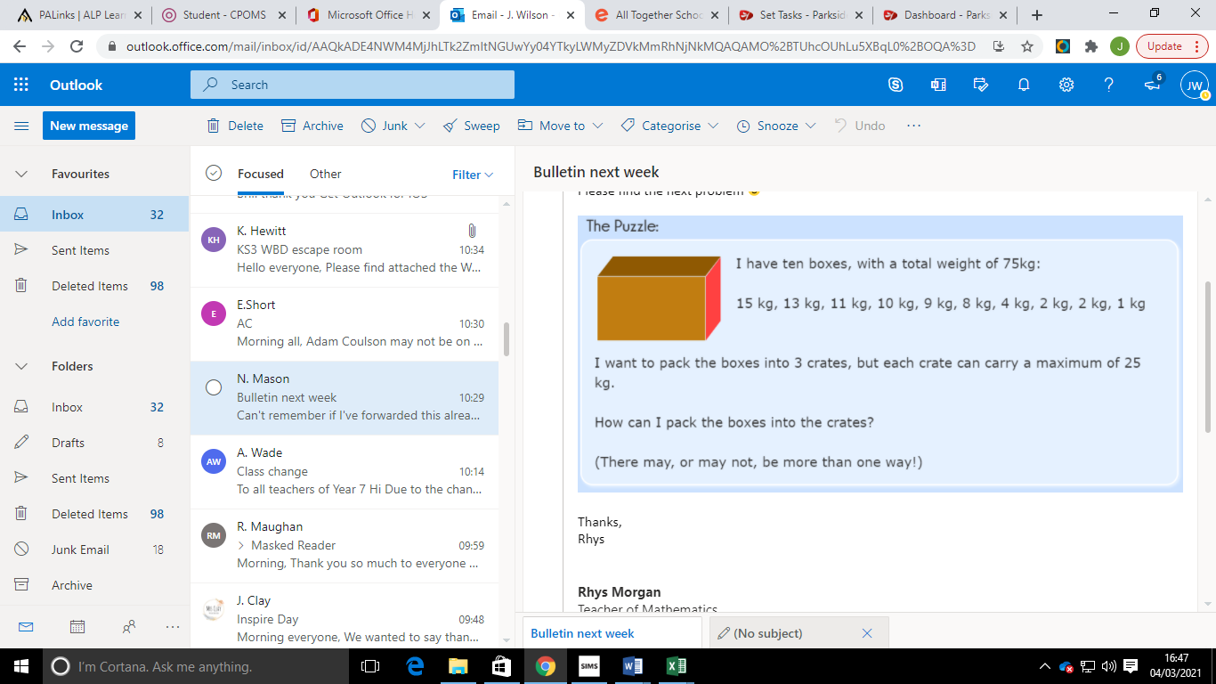

**Swap Shop/Benevolent Fund**

Reminder: We have the uniform Swap Shop in school if you require any items of uniform. Parents may also apply to the benevolent fund who can help with coats and shoes. If you have any questions, please get in touch.









**Are you looking to relax and unwind?**

Donna will be hosting Relaxed Yoga on a Tuesday afternoon at 3pm.

Year 9 Bulletin

*8th March 2021*

**Parkside’s Pastoral Focus**

