inheritance &

sex determination

Tuesday, 02 February

Male – XY

Female – XX

The male gamete determines the sex of the baby as the female egg cells can only be X but male sperm cells can be X or Y.

Cystic Fibrosis

* **Recessive** disorder
* Faulty allele
* Internal organs / digestive system becomes covered in mucus
* Must have **two** copies of the faulty allele to pass on cystic fibrosis
* If the parents are **heterozygous** then they will not have the disorder
* Probability in this situation of children getting cystic fibrosis is 25%
* 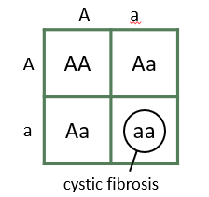

Polydactyly

* Causes someone to have extra fingers or toes
* Caused by a rare, **dominant** allele
* Only needs **one** copy of the faulty allele
* The parent is **heterozygous**
* Probability in this situation is 50%
* 