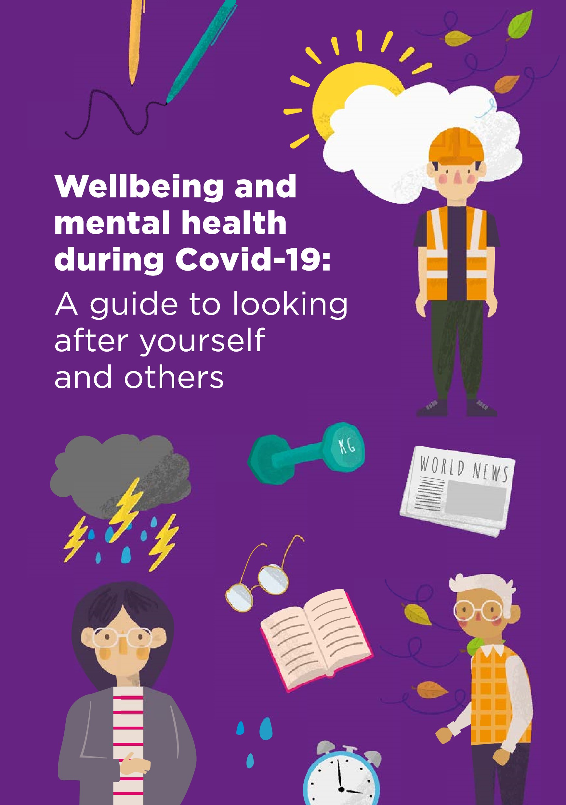

**Contents**



**3**

**4**

**5**

**6**

**9**

**11**

**14**

**15**

**16**

**17**

**18**

**19**

**20**

**21**

**22**



Looking after **yourself**

**Beating** corona anxiety

**Manage** your stress bucket

Looking after **your wellbeing**

Struggling to **cope**

**Wellbeing** plan

Jar of **hope**



**Supporting** young people

**Work well** from home

Looking out for **others**

Five steps to **helping others**

Spot the **signs**

**Listening** tips

**Thoughts** of suicide

Getting **help**

**03**

# Looking after **yourself**

**Covid-19 has now had a far reaching impact on people right across the world and it’s important during this time to take care of your mind as well as your body.**



Everyone will be reacting in their own way. You might be feeling frustrated or lonely. Concerned about your finances, your health or relatives. And you might be feeling down, worried or anxious.

It is OK to feel like this. These are normal reactions to uncertainty and to challenging events.

Covid-19 has also impacted on many of the normal coping strategies we use to deal with stress, and on the everyday activity that underpins our emotional wellbeing. During this time, we may need to be more creative and thoughtful about how we look after ourselves.

This booklet contains practical information about things you can do now to look after your mental health and wellbeing, and how you can support others.

**04**

## Beating corona anxiety

### **It’s natural to feel anxious about what’s happening right now, but if it begins to feel too much follow**

**our top tips.**

#### Limit your news coverage

Avoid constantly checking the news – it only makes your anxiety grow stronger. Limit yourself to 30 minutes a day or particular broadcasts. **Concentrate on the facts**

Use reputable sources for news, advice and opinion such as the BBC. Be cautious of social media coverage. **Focus on what you can control**

We can’t control the Covid-19 crisis but we can control our own responses and behaviours to it. Think ahead, make plans for what you’ll do in the

WORLD NEWS

WORLD NEWS



#### Connect with others

Reach out and connect with friends and family, in safe ways. Share your fears or talk about nothing in particular. **Be nice to yourself**

Add extra time for stress relief in your day. Treat yourself whenever you need and do things you enjoy, within the limits of existing restrictions.

#### Hold on to hope

Keep the big picture in mind. The crisis will end, and we will get through this.

coming days and weeks. **Distract yourself**

Our minds struggle to hold two thoughts at one time. Distract yourself with exercise, games, books, movies or other activities.

**05**

# Manage your **Stress Bucket**

**Stress is a part of everyday life. It can help us take action and work productively. But if our Stress Bucket becomes full it can also overwhelm us and impact negatively on our mental health.**

**06**

Looking after **your wellbeing**

**Connect with people**

Connections with other people are the bedrock of our mental wellbeing.

Though contact with others is challenged by current restrictions it is more important to maintain than ever. You may not be able to pop round for a cuppa or meet with friends in the pub but you can still connect - FaceTime, telephone, text, social media, a conversation over the garden fence, or even write a letter!

## Share your worries

It’s normal to feel worried or helpless about the current situation and how its impacting on you. Share your concerns with people you trust - it may also help them to talk about it – or if you are feeling isolated from other people there are a number of helplines and online forums where you can find a listening ear.

**Social distancing is about physical distance not emotional distance**

**Help others**

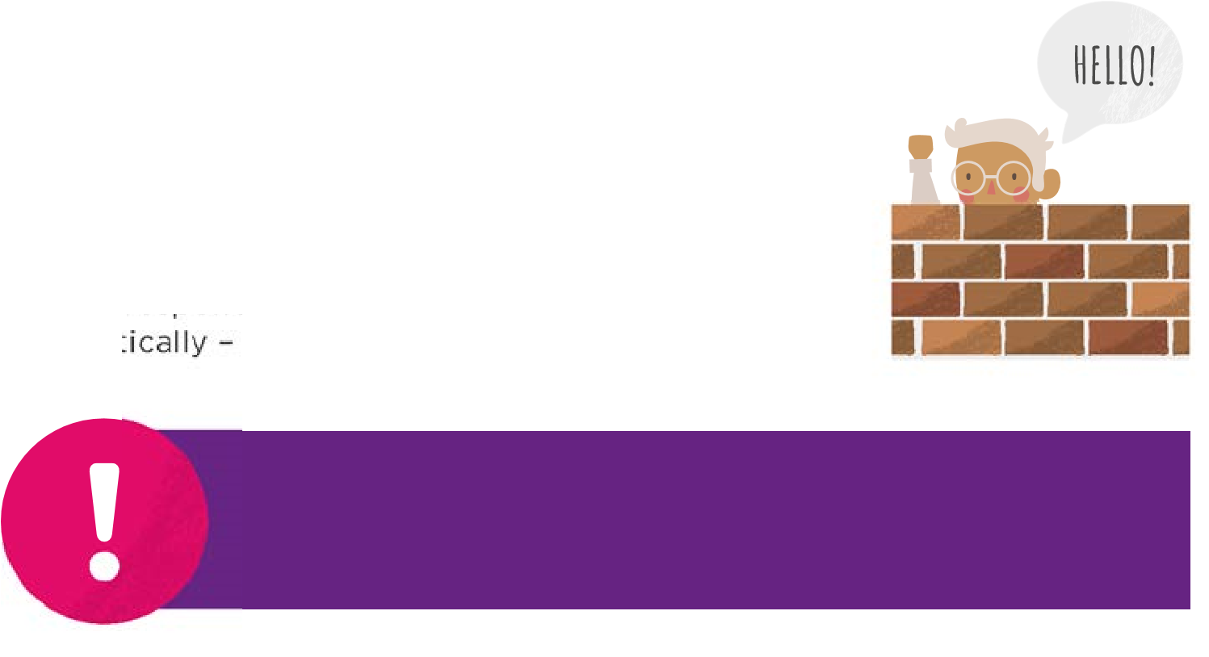Helping others is a sure fire way of boosting your wellbeing, and now is a time when giving to others can make a real difference. There are a large number of volunteering opportunities to support the Covid-19 response, such as being an NHS responder – but also the opportunity to help practically – shopping for a neighbour and so on.

**One of the most important things you have to offer right now is your time. Make contact with others, reach out, check-in and to show you care.**

**07**

Looking after **your wellbeing**

## Stay healthy

KG



Our physical health really affects how we feel.



|  |  |  |  |
| --- | --- | --- | --- |
| **• •**  **•** | Eat as healthily as you can and drink enough water.  Stay active indoors. There is a wide range of online or TV exercise programmes, for all ages. Or develop your own indoor workout, set yourself challenges and plan a daily routine.  Green spaces boost our wellbeing. Go out for a walk or run, spend time in your garden. | **•**  **•**  **•** | Getting enough sleep can really impact how we feel – be sure to maintain a regular sleeping pattern.  Avoid drugs and too much  alcohol. It’s easy to fall into unhealthy coping patterns that make you feel worse.  Plan how you will continue accessing treatment and support for any existing physical or mental health problems if possible. |

## Keep your mind active

Keeping your mind active and learning new things is good for your wellbeing! And a perfect distraction during these challenging times.

Get creative! Draw, colour, make a playlist, bake, write a song… Get a new hobby! Play guitar, learn to cook, try a new exercise….

Home school! There are 1,000’s of online courses waiting for you…

Pay attention! Take time to look at what’s going on around you…

**Mindfulness can help positively change the way you feel about life and how you approach challenges. Look for free mindfulness apps or search online for how to start.**



**08**

## Know your employment and benefits rights

Work and money worries created by Covid-19 can have a big effect on your mental health. Visit our website for links to more information and organisations that can advise you about money, employment and benefits during Covid-19. Don’t delay.

**Make Plans (but be realistic about what you can achieve!)**

|  |  |  |  |
| --- | --- | --- | --- |
| **• •**  **•** | Get productive! Make a To Do List of jobs around the home.  Work out what household supplies you need and how you can get them. If you can’t get out yourself ask a friend or try a home delivery service.  Contact your GP or Pharmacist to discuss how you can get any ongoing medicine | **•** | or repeat prescriptions delivered, or collected.  Make the most of your time! This could be the perfect opportunity to take up a new hobby, read those books you always wanted to read, pick up that guitar that has been gathering dust in the corner. |

## Physical Environment

For some people having a clean and organised home environment can really help lift their mood.

## Routine

Having a routine is particularly effective at warding off anxiety and worry.

* Write a timetable for your week
* Pick regular times to exercise, eat, watch TV, read, do a crossword etc
* Maintain normal sleep patterns
* If you work from home set regular hours
* Build in regular time to keep in contact with people
* Set yourself goals and build in new activity to your weekly plan.

**09**

## Struggling to cope

**It’s important to recognise that some people will feel so overwhelmed they need professional support, and some may even think about suicide.**



Whether you are struggling to cope with difficult emotions, or are having thoughts of suicide, there is hope and you are not alone.

|  |  |  |  |
| --- | --- | --- | --- |
| **•**  **•** | Share your feelings with a good **•** friend, a relative or a work mate. | | Contact your GP or ring NHS 111. Be open about how you are feeling. Talk to a friend and plan what you want to say, and if possible get someone you live with to accompany you.  Other services and support are listed in this booklet and on our website www.stopsuicidenenc.org including talking therapies, peer support groups, online help and apps. |
| If it feels hard to find the words, speak to someone  who is trained to listen, like the Samaritans on 116 123, or other telephone/text helplines. You can talk to them about whatever’s getting to you, in your own way, and they can also help you explore the range of help available. | **•** |

**If you are really struggling to cope, or feel overwhelmed by difficult feelings, then reach out for professional help. It’s still available and it’s OK to ask for more support to see you through this difficult time.**



**010**

## Struggling to cope

**Thoughts of suicide are not uncommon – a lot of people will have them - around one in five of us during our lifetime. Having these thoughts doesn’t make it inevitable that you are going to take your own life.**



If you are having thoughts of suicide focus on what you need to do to keep yourself safe for now. Visit www.stopsuicidenenc.org to complete a Safety Plan and learn more about what practical steps you can take to keep yourself safe. This can include:

|  |  |
| --- | --- |
| * Finding ways to distract yourself that allow the feelings to pass * Calling a helpline or someone you can trust * Avoiding using alcohol and drugs * Removing things from your house that you could use to harm yourself | * If you can, going somewhere you feel safe * Knowing who you can contact if you need professional support – this might be your key worker, your GP, NHS 111 or others * Making a Hopebox – a list, or photos, or objects that remind you of why you want to live. |

**If you feel you can’t keep yourself safe any longer, or if you have done something to harm yourself – call 999 now. The number is free.**

**Thoughts of suicide do pass and there are things**

**that you and other people can do to make your**

**situation better.**



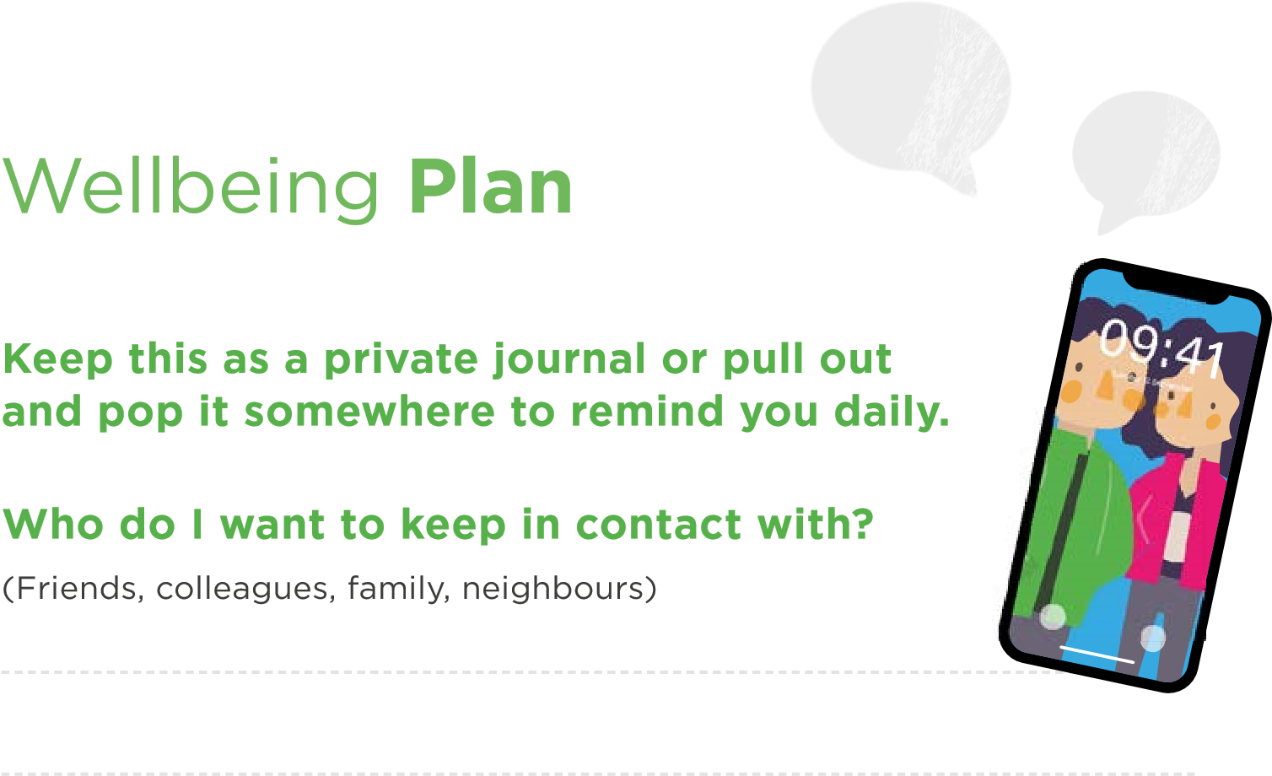

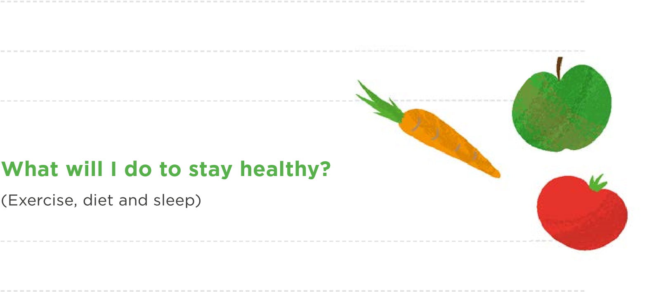**How will I help others?**

(Keeping in contact with people, volunteering, giving practical support)

|  |  |
| --- | --- |
| **8am**  **9am**  **10am 11am**  **12pm**  **1pm**  **2pm**  **3pm** | **6pm**  **7pm**  **8pm**  **9pm**  **10pm**  **11pm**  **12am**  **1am** |

### **7am**

**013**

**How can I tell when things are getting too much?**

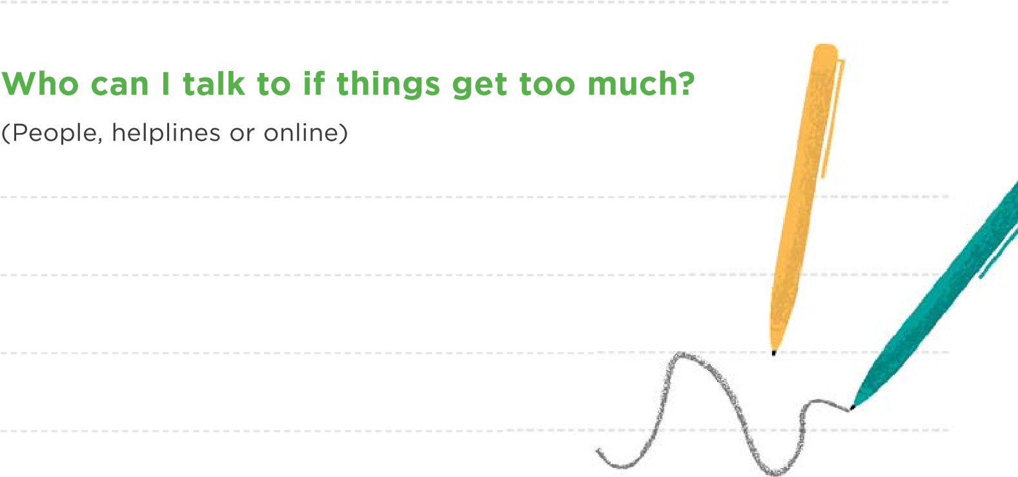(Feeling snappy, sleep issues, feeling low, eating more or less, drinking more)

**What will I do to distract myself when I feel stressed, anxious or down?**

(Treat myself, phone a friend, go for a walk, mindfulness, watch Netflix)

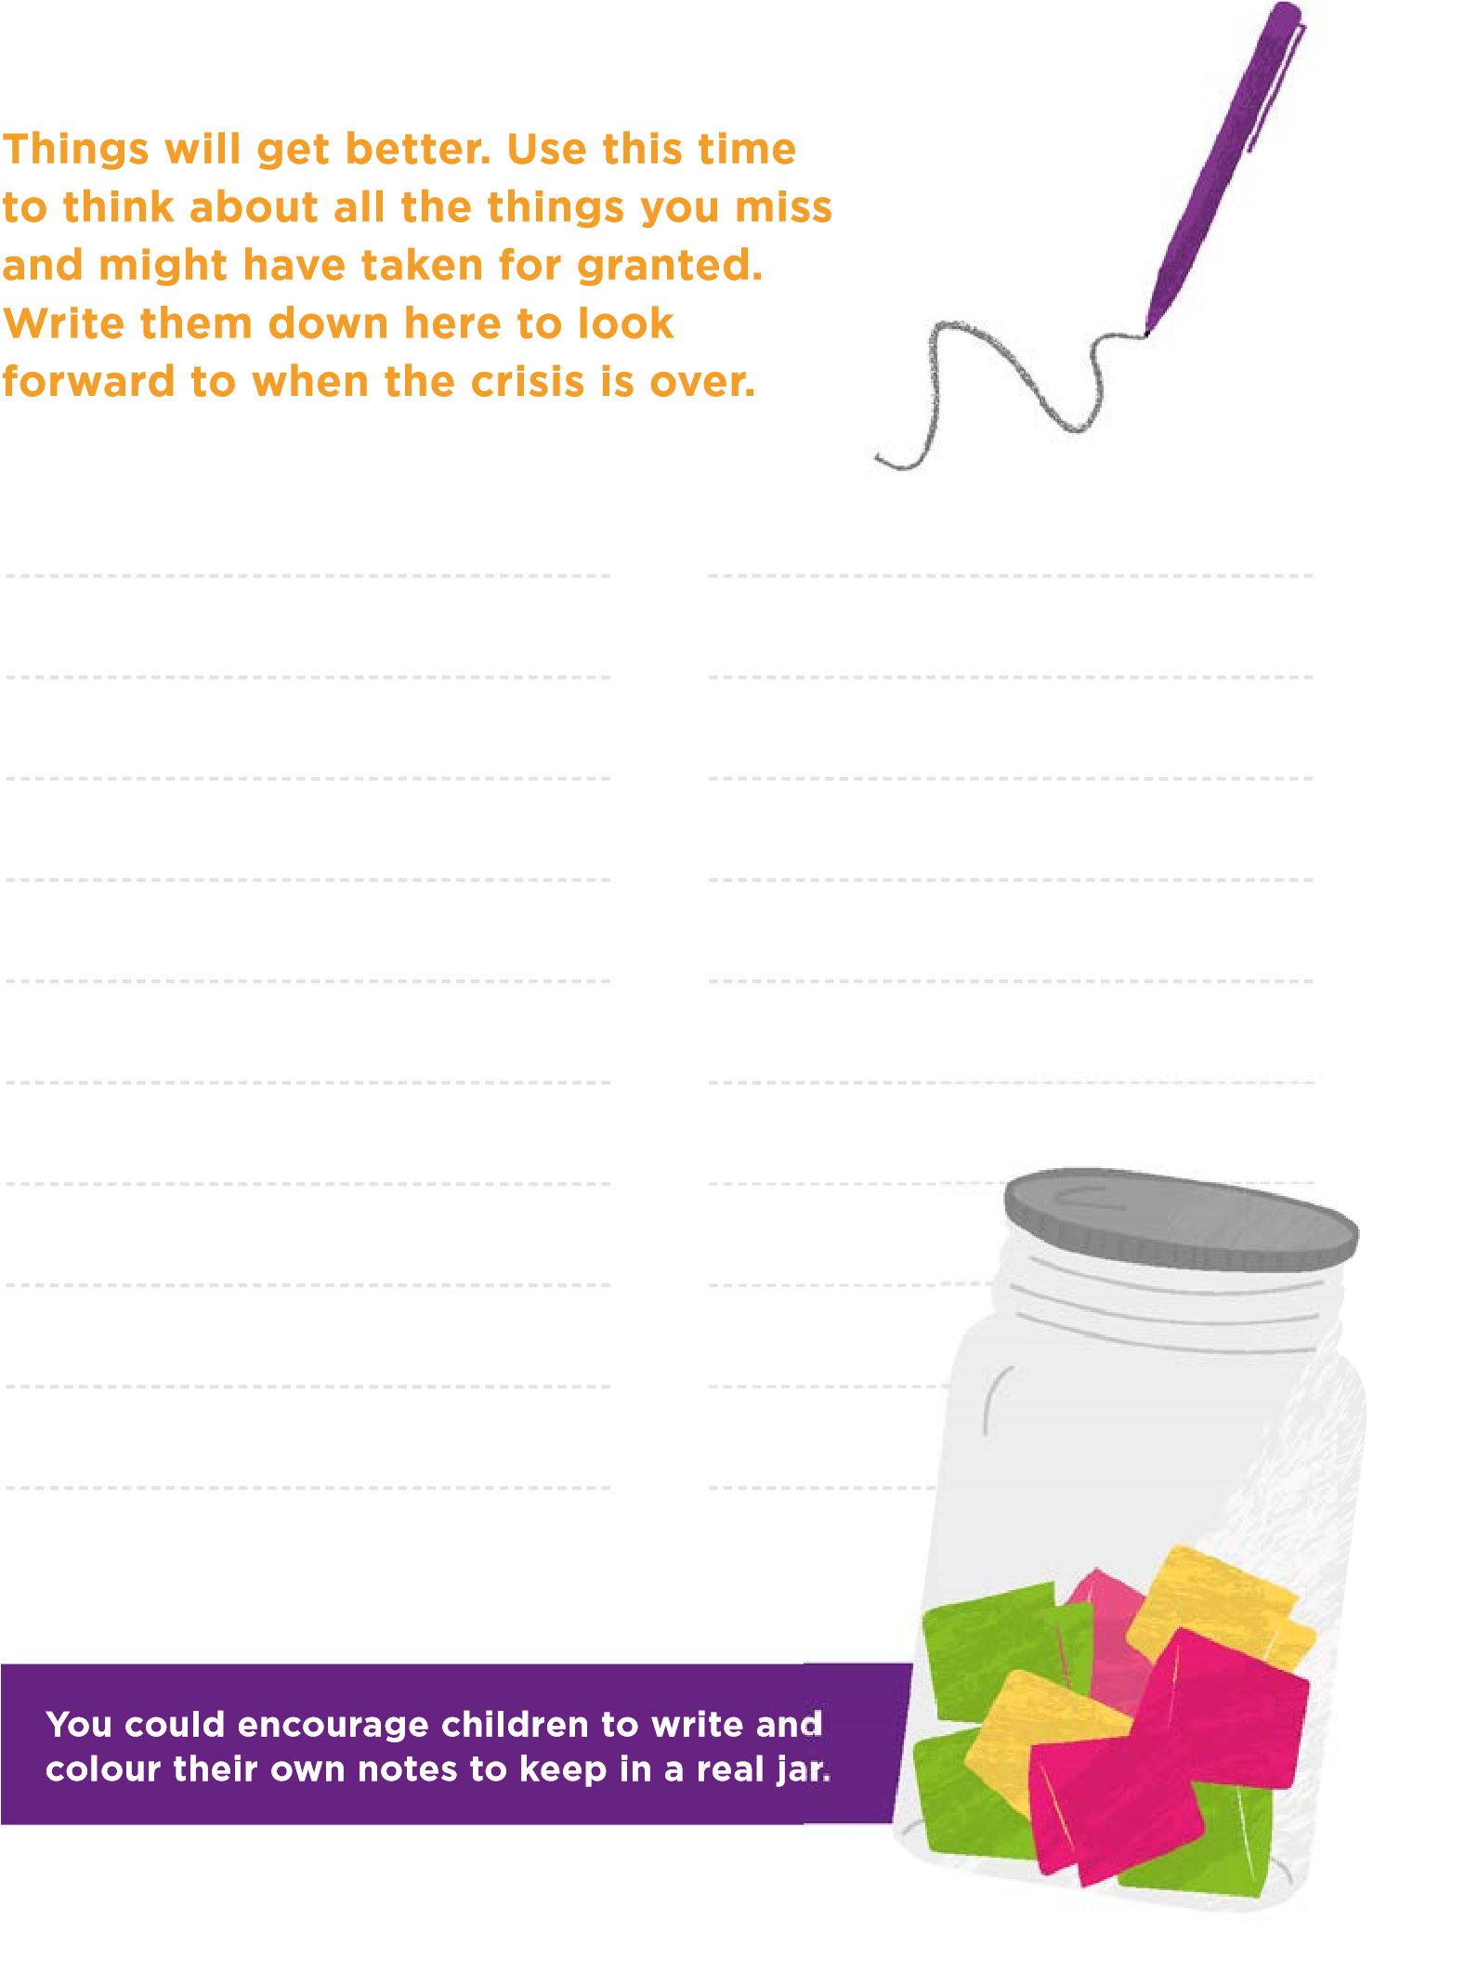**014**

Jar of **hope**

**015**

### **Supporting** young people

The sudden change in children and teenager’s routine, combined with the Covid-19 crisis will be unsettling, and younger ones might find it difficult to understand what’s happening and why everyone is so worried. But there are lots of things we can do to look after children’s mental health and wellbeing during this crisis.

**Be kind to**

**yourself and stay**

**flexible!! Juggling**

**working from**

**home and looking**

**after children is**

**challenging.**



**Beat corona anxiety for Kids**

* Create a routine and structure
* Keep them connected with friends
* Re-assure them they are safe
* Let them talk about their worries
* Teach them coping skills
* Limit their exposure to news

**Talking to children about Covid-19**

* Children may not talk **•** directly about Covid-19 but still check-in with them.
* Explain its normal to feel

scared or unsure. **•**

* Be honest, speak calmly, use age appropriate language.
* Reassure them that **•** elderly family members are being looked after.

Pay attention to individual worries, these may seem trivial to you, but may feel important to your child.

You don’t need to have all the answers, if you don’t know you can find out together.

Explain how they can help. For instance, good hygiene and social distancing, and how this can keep them and

others stay safe.

**Visit our website for sources of advice on young people’s mental health.**

**Create a structure and routine. This is an important**

**way children manage their anxiety and other emotions.**



|  |
| --- |
| **016**  **Work well** from home  **For many of us home working is now the standard. Here’s a few simple ways that you can focus on improving your wellbeing whilst** |

**still remaining productive.**

#### Get work ready

Shift your mindset. Set a designated space in your house to work from. Ditch the hoodie, think about dressing as if you are leaving for work!

#### Set schedules and goals

Set yourself some simple goals for the day and break your work down into bite sized portions. Schedule regular breaks and leave your workspace.

**Give yourself some**

**Slack. Adapting**

**to home based**

**working takes time.**

**Be patient, and be**

**kind to yourself.**

**Be flexible**

It can be hard to focus at home,

so be flexible. Adapt your working

hours to the way your home runs.

Spend time with the kids and

work in the evening.

**Get fresh air**

Make sure you get time

to leave the house, even

if it’s your garden, or

leaning out a window.

Go for a walk, run or

ride if you can.



#### Connect with colleagues



Workmates are a big part of our life. Connect through virtual meetings, Skype or a phone call. Keep the conversations and banter going. **Circle of support**

If you are struggling to cope, reach out to your colleagues, or too any support schemes your workplace or union offers. Check in with your workmates and look out for each other.

**017**

#### Looking out for others

**Be Vigilant – In the absence of face to face contact it’s more important than ever to find other ways to check-in, to keep contact and to offer support to those around us.**

During periods of social isolation, it might feel more difficult than ever for people to look after their mental health. For some the mix of Covid-19 related anxiety, social isolation and pre-existing mental health problems could be particularly difficult to cope with. In addition, the current situation may have taken away some people’s previous coping mechanisms, and their access to face-to-face support.

**We can all play a role in helping people whose**

**mental health is at risk. Showing you care, offering**

**support and a listening ear can all go a long way.**



**Mental health support is still available for people who need some extra help to get through.**

In addition to offering practical and emotional support we can help others by making them aware of the range of services and support still available to:

* Support their mental health
* Address the broader range of problems that arise out of the crisis such as housing, money, domestic violence and employment issues.

**Pass on the information at the end of this booklet or visit www.stopsuicidenenc.org for more information about support available.**

**018**

Five steps to **helping others**



##### Be AwareBuild Support

Watch for the warning signs that someone might be struggling. This is more challenging during the Covid-19 crisis, and we may need to be more pro-active about checking in with others by phone and online.



##### Ask

Trust your instincts and ask the person directly how they are doing. If necessary, ask twice. “Are you really OK?”. If you feel they may be struggling let them know that you are worried about them and that you care.

0

9

:

4

1

T

u

e

s

da

y

1

2

S

e

p

t

e

m

b

e

r



##### Listen

Give them time and space to talk and be helpfully nosy. Have a look at our listening tips on the following pages. During the Covid-19 crisis you may need to do more of this by telephone and online.

Explore what help they might need. Build a circle of support through family and friends. Have a look together at the resources at the end of this booklet, or on our website. Set goals about what they can do next.



##### Check-in

Keep checking in and letting the person know you are there for them. Knowing someone cares can make all the difference.

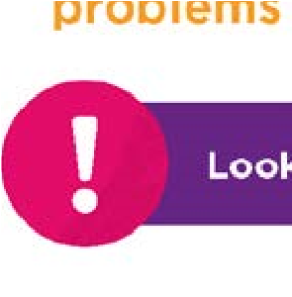

|  |  |
| --- | --- |
| Spot the **signs**  **019**  **The current situation and uncertainty will lead to heightened levels of anxiety for many people, and potentially in the longer term to a range of mental health problems if people don’t get the early support they need.**   |  | | --- | | **Look out for signs that someone may be struggling to cope** | |

**How someone might behave •** Changes in appetite or sleeping patterns **•** Withdrawing from, or avoiding friends and family **•** Stopping telephone or social media contact **•** Losing interest in things, including their appearance **•** Risky behaviour or increased use of alcohol and drugs **•** Carelessness or lack of interest in work **•** Starting or increasing self-harming behaviour **•** Increasing coping behaviour such as hand-washing **•** Struggling to make decisions and concentrate.

##### Be helpfully nosy

###### **How they may be thinking or feeling**

**•** Sadness or anxiety that does not go away **•** Losing enjoyment and interest in people and activities **•** Lack of energy, lethargy and tiredness **•** Extreme mood swings,

|  |
| --- |
| This is a challenging time. Show interest in the people around you. Show you care through asking questions about how they are thinking and feeling. And don’t be afraid to ask twice if you are worried.  Check in, and continue to check in. |

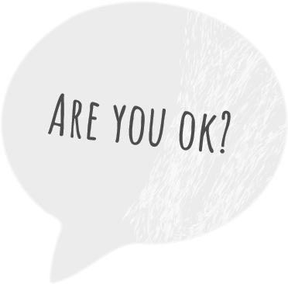ongoing irritability or anger **•** Developing unrealistic or excessive fears and worries **•** Increased anxiety about their health **•** Chest pains, shortness of breath

Avoid offering solutions

Listening to someone’s problems is not always easy – and most of us want to make things better, but this not usually helpful. Avoid fixes such as ‘Have you thought of doing this?’ or ‘You should try that’.

Ask open questions

These are questions that invite someone to say more than ‘yes’ or ‘no’, such as ‘How have you been feeling?’ or ‘What happened next?’ **Offer prompts**

Encourage someone to talk more through phrases such as ‘Tell me more’ or ‘Can you say more about that?’, or through repeating back important words they say.

Give them time

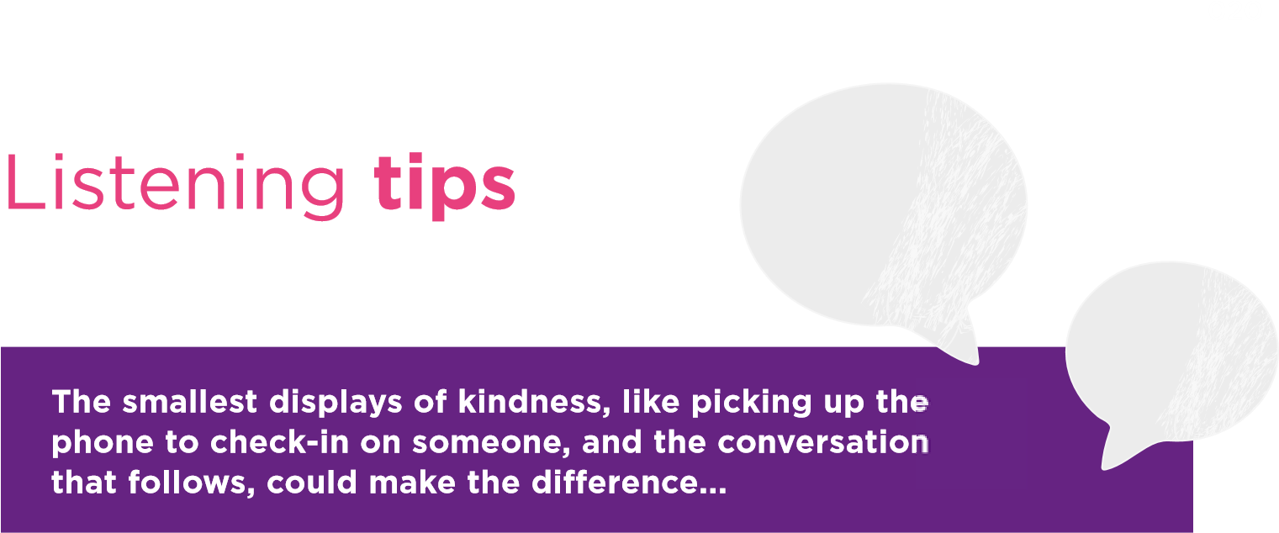It helps if you let them take the time they need to describe where they are at. Make sure you have time to listen.

Take their feelings seriously

Take whatever they say seriously and without judgment. Don’t offer platitudes or minimalize their feelings.

Avoid judgements

You might feel shocked or upset by what someone says, but it’s important not to blame the person for how they are feeling. It may have been a big step to talk to you, and to place their trust in you.

You don’t have all the answers

It’s okay to not know what to say! You’re a human being too and what you’re hearing might be upsetting or confusing. If you don’t know what to say – be honest and tell that person.

Give reassurance

Let the person know there is help available and that you care about them.

**021**

##### Thoughts of suicide

**Being there to listen and to provide emotional support can be a lifesaver.**

If you’re worried that someone you care for may be feeling suicidal it can be really hard to know what to say to them, or how to help. But thinking about suicide does not make it inevitable that someone is going to take their own life, and all of us have the ability to support someone who is experiencing thoughts of suicide, and to save lives.

**Trust your gut instincts. If you are at all concerned that someone is having thoughts of suicide - ASK them directly - LISTEN compassionately - GET HELP if needed.**



**In addition to the general signs of mental health problems listed earlier someone having thoughts of suicide might:**



|  |  |  |  |
| --- | --- | --- | --- |
| **•**  **•** | Talk, or post social media messages, about wanting to die, feeling hopeless, trapped or having no reason to live, or that they are a burden to others.  Show unexpected mood changes such as suddenly being calm after a long period of depression, giving | **•** | away possessions or making a will, increased risky behaviour or self-harming, or researching suicide online.  Have had by a major loss or change in their life, an accumulation or build-up of problems before Covid-19, or be facing financial, relationship or housing hardship. |

Talking about suicide with someone can feel nervewracking but the best thing to do is ask directly. “Are you thinking about suicide?” This will not put ideas in their head and will show them they don’t have to struggle alone with these overwhelming thoughts.

**Visit www.stopsuicidenenc.org for more information on how to help someone with thoughts of suicide.**

**022**

###### Getting **help**

**There may be times when we need some extra support**

**to get through - Its ok to ask for help, and there’s lots**

**of support out there.**



For more details about help and support available during

Covid-19 go to **www.stopsuicidenenc.org**

Telephone/Text Helplines

**Samaritans 116 123**

Whatever problems you are facing Samaritans are there to listen 24/7

**SHOUT Text Shout to 85258**

Crisis text service for support with any mental health concern 24/7

**CALM Campaign Against Living Miserably 0800 58 58 58**

Helpline for men of all ages 5pm – Midnight.

**Silverline 0800 470 80 90**

Information, friendship and advice for older people 24/7

**Young Minds Parent Line 0808 802 5544**

Advice for parents and carers worried about a young person 9.30-4pm Mon-Fri.

**Young Minds Crisis Messenger Text YM to 85258**

Crisis text support for under 25s 24/7

**Papyrus Hopeline 0800 068 4141**

Support and advice for

Young People. 9am-10pm Mon-Fri. 2-10pm Weekends.

**The Mix 0808 808 4994 www.themix.org.uk**

Advice and support for under 25s 4-11pm

**Childline 0800 11 11**

Support currently available

9am-Midnight and online

1-2-1 chat www.childline.org.uk

**Advice and Guidance**

Kooth

Free online counselling for young people over 11. www.kooth.com

Mind

Mental health information and self-help guides www.mind.org.uk

Online Self-help Guides

For a range of mental health issues web.ntw.nhs.uk/selfhelp/ www.selfhelpguides.ntw.nhs.uk/ tewv/

Recovery College Online

Information and online courses www.recoverycollegeonline.co.uk/

Every Mind Matters

UK Government Mental Health and Wellbeing advice including NHS recommended Apps www.nhs.uk/ oneyou/every-mind-matters/

Good Thinking

Online wellbeing resources www.good-thinking.uk

Suicide Prevention

Information and advice at www.stopsuicidenenc.org



**023**

NHS Support

NHS 111

For NHS advice and referral for any health or mental health related issues 24/7

Covid-19

**For the latest information about Covid-19**

www.gov.uk/coronavirus

Local authority community support lines

If you want to find out what support is available in your area, and you would prefer to speak to someone, please call your local council on the relevant number below.

Cumbria 0800 783 1966

Northumberland 01670 620 015 Newcastle 0191 277 8000

North Tyneside 0345 2000 101

Gateshead 0191 433 7112

South Tyneside 0191 424 7575

Sunderland 0800 234 6084

County Durham 03000 260 260

Darlington 01325 405 000

Hartlepool 01429 272 905

Stockton-on-Tees 01642 524 500

Middlesbrough 01642 729 777

Redcar & Cleveland 01642 774 774 North Yorkshire 01609 780 780

