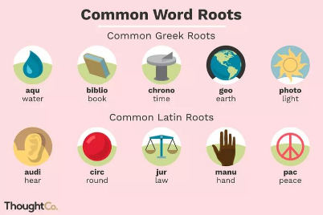
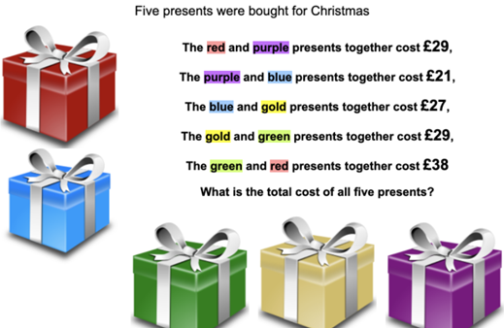
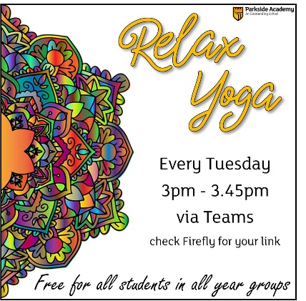



Are you having trouble accessing your live lessons? Ask a parent or carer to contact remotelearning@parkside.org.uk and issues will be resolved.
Top Achievement Points
(we gained 935 points last week!)
The following pupils were awarded the highest number of achievement points last week – fantastic!

Anna N (7D) – 32 points

Isobel M (7I) – 31 points

Alfie S (7D) – 28 points

Lily S (7I) – 28 points

Lucy O (7P) – 26 points

SMSC:
Our mental health is something that we can’t take for granted, we need to be able to look out for ourselves as well as others. What can you do to help your mental health? Read a book, go for a walk, chat to a family member or friend.
We need to look after ourselves.

Numeracy Challenge:

Literacy Challenge:
How many words do you know that contain these common roots?

Parkside’s Pastoral Focus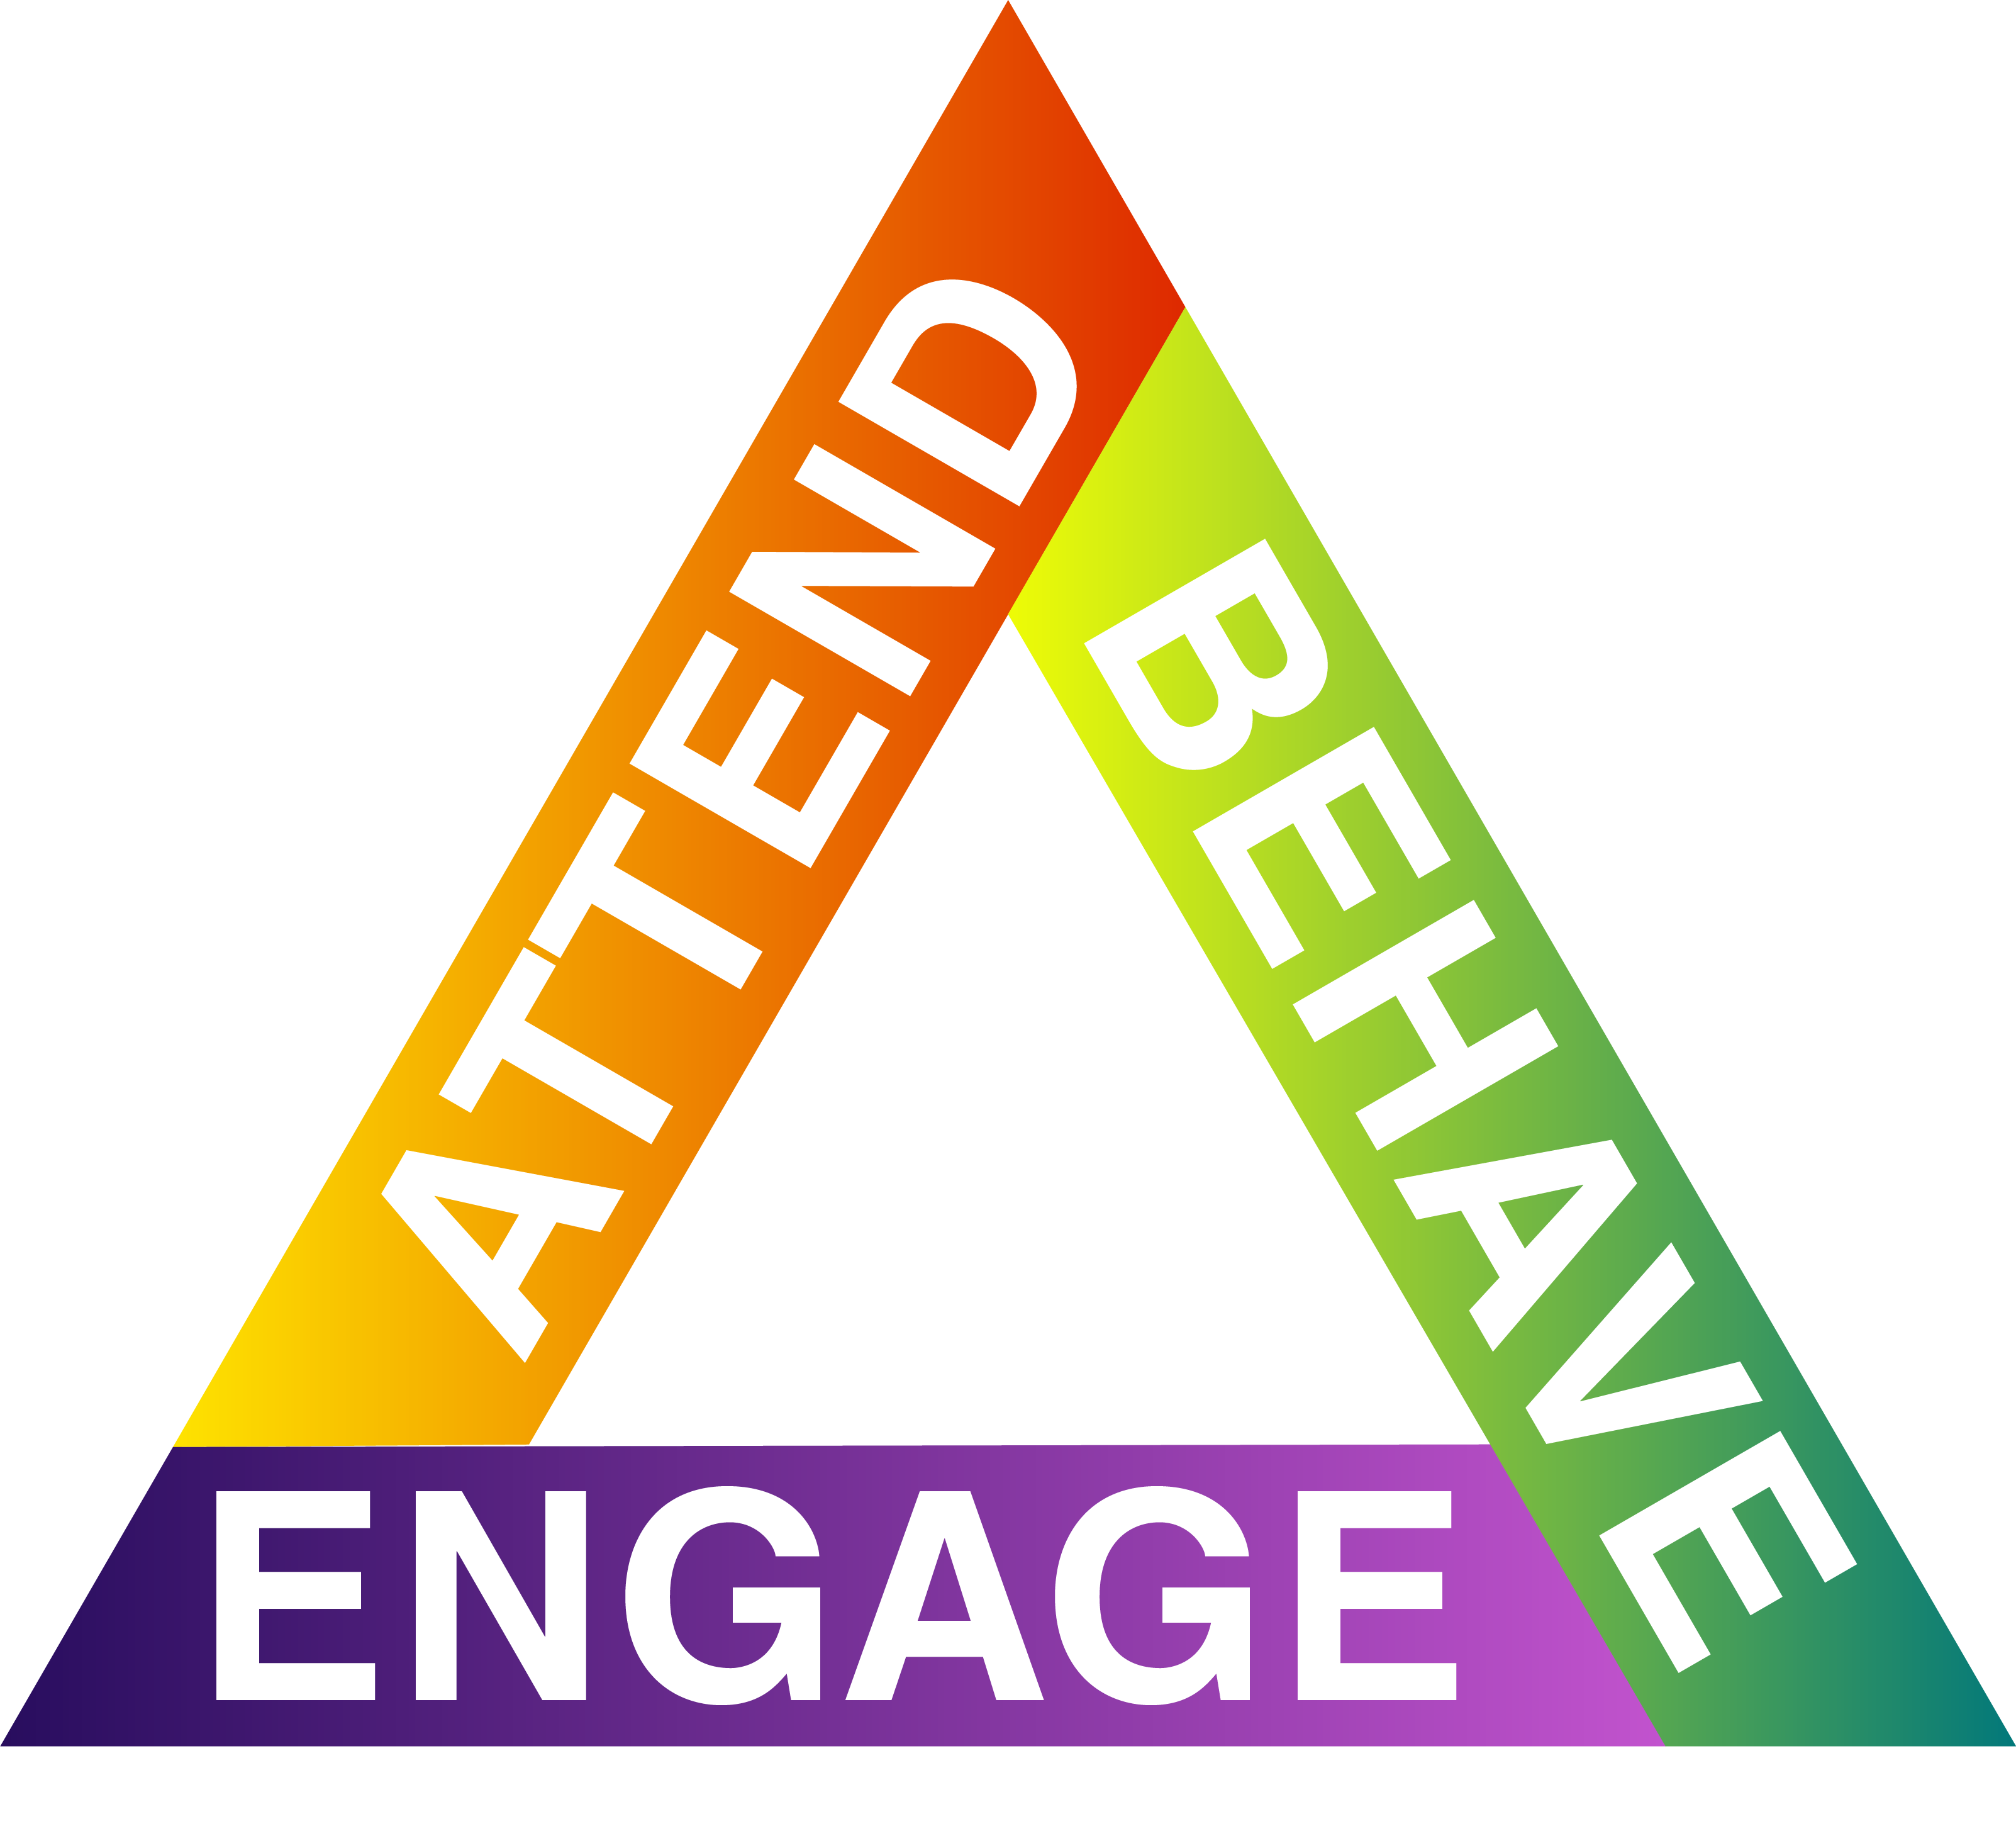

Subject Live Lesson Shout Outs

Maths: Aiden G for an excellent book review.
Ethan C, Izzy G, Sophie N and Isaac G.

Art: Caitlin M, Corey M and Alex D

Tech: Jacob D

RE: Jessica W

History: Aiden G, Lewis K, Tyla B, Tom M, Kallum C,
Charlie T

The Science Department are
launching Science @Home.
A Science experiment will be posted each Saturday morning on Facebook for you to try at home. It would be great to see you getting involved.

Year 7 Bulletin
1st February 2021
A message from Miss Makinson
Welcome to week 20 of the academic year!

We are now entering February, which means a new month and a new start. Try and stay positive as you have all been doing an amazing job with remote learning throughout this difficult time. I continue to receive emails and shout outs from your teachers about the level of outstanding work that you are producing so please keep this up.

Please remember that if you need anything at all, you can get in touch with your tutors, or me and we will solve any issues that you are having.

Continue to follow your daily timetables and access all of your live lessons, including registration. All tasks/lessons are set on Firefly.

Don’t forget we have our Year Group Drop In on Wednesday at 4pm. I will set the link as a task on Firefly. We will be having an attendance draw during the drop in session, so make sure you’re there for the opportunity to win a prize. Have a great week everyone!

